**Battery Level Indicator Circuit Principle:**

Prabhakar Tripathi (14BEC090)

The heart of this battery level indicator circuit is LM3914 IC. This IC takes input analog voltage and drives 10 LED’s linearly according to the input analog voltage. In this circuit there is no need of resistors in series with led’s because current is regulated by the IC.Battery level indicator indicates the status of the battery just by glowing LED’s. For example six LED’s are glowing means battery capacity 60% remains. This article explains you how design battery level indicator. You can use this circuit to check car battery or inverter. So by using this circuit, we can increase the lifetime of battery.This circuit is designed based on lm3914 IC (Integrated chip). This IC is LED dot/bar display driver.

### ****Battery Level Indicator Circuit Diagram:****

[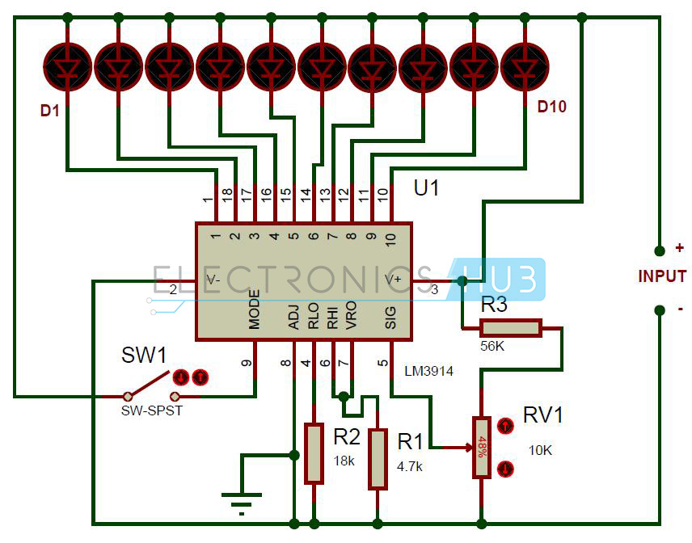](http://www.electronicshub.org/wp-content/uploads/2014/07/Battery-Level-Indicator-Circuit-Diagram.jpg)

**Circuit Components:**

* Lm3914 IC
* LED’s -10
* SPST switch
* Resistors -18k,4.7k, 56k
* Potentiometer – 10k
* 12V battery
* Connecting wires

#### ****Battery Charge Indicator Circuit Design:****

In this circuit LED’s (D1-D10) displays the capacity of the battery in either dot mode or display mode. This mode is selected by the external switch sw1 which is connected to 9th pin of IC. 6thand 7th pins of IC are connected to the ground through a resistor. This resistor controls the brightness of LED’s. Here resistor R3 and POT RV1 forms potential divider circuit. Here pot RV1 is used for calibration. There is no need of any external power supply to this circuit.

The circuit is designed to monitor 10V to 15V DC. The circuit will work even if the battery voltage is 3V. The operating voltage of this IC is 3v to 25v DC. Lm3914 drives led’s, LCDs and vacuum fluorescents. The IC contains adjustable reference and accurate 10-steps divider. This IC can also acts as sequencer.

##### **Lm3914 Features:**

* Internal voltage reference from 1.2 to 12v DC.
* Programmable output current 2mA to 30mA.
* LED driver outputs are current regulated.
* No multiplexing interaction between outputs.
* It supports wide range of temperature from 0 to 70 degree Celsius.
* For bar graph display – connect 9th pin of IC to the supply
* For dot display – leave the 9th pin of IC

We can also connect different color led’s to indicate the status. Connect D1 to D3 red LED’s which indicates shut down stage of your battery and use D8-D10 green color LED’s which indicates 80 to 100 percentage of the battery and use yellow color for remaining.

With a little modification we can use this circuit to measure other voltage ranges also. For this remove the resistor R2 and connect upper voltage level to the input. Now vary the resistance of Pot RV1 till the D10 LED glows. Now remove upper voltage level at the input and connect lower voltage level. Connect a high value variable resistor in the place of resistor R2 and vary it till the D1 LED glows. Now disconnect the pot, measure the resistance across it and connect resistor of same value in place of R2. Now the circuit is ready to monitor other voltage ranges.

This circuit is most suitable for indicating 12V battery level. In this circuit each led indicates 10 percent battery level. We can extend this circuit to 100 steps by cascading lm3914 IC’s.

**How to Operate Battery Level Indicator Circuit?**

* Connect 12V DC battery to the input.
* Now adjust the pot RV1 so that LED D1 just starts glowing.
* Now increase the input Dc voltage slowly and observe the LED’s
* First led will glow for 1.2V and second LED is for 2.4 V and so on.

Below table shows the status of LED’s with input voltage level.

| **BATTERY LEVEL** | **PERCENTAGE** | **STATUS OF LEDS** |
| --- | --- | --- |
| 1.2V | 10 | D1 - ON |
| 2.4V | 20 | D1, D2 - ON |
| 3.6V | 30 | D1, D2, D3 - ON |
| 4.8V | 40 | D1, D2, D3, D4 - ON |
| 6.0V | 50 | D1, D2, D3, D4, D5 - ON |
| 7.2V | 60 | D1, D2, D3, D4, D5, D6 - ON |
| 8.4V | 70 | D1, D2, D3, D4, D5, D6, D7 - ON |
| 9.6V | 80 | D1, D2, D3, D4, D5, D6, D7, D8 - ON |
| 10.8V | 90 | D1, D2, D3, D4, D5, D6, D7, D8, D9 - ON |
| 12V | 100 | ALL LEDs - ON |

**Battery Charge Level Indicator Circuit Applications:**

* We can use this circuit to measure car battery level.
* This circuit is used to calibrate inverter status.

**Limitations of the Circuit:**

* This battery level indicator works only for small voltages.
* This circuit is theoretical and may require some changes to work in practical